**Introduction to Loop Structures and Conditionals in Python:**

Fundamental ideas in programming, such as loop structures and conditionals, allow programmers to write responsive and dynamic programs. When writing code in Python, loop structures enable code blocks to be executed repeatedly, whereas conditionals allow for decision-making based on predetermined circumstances. Programmers can create practical and adaptable solutions by comprehending these ideas. They can expand their skill set by learning from [**online training on Python**](https://www.h2kinfosys.com/courses/python-online-training/)**.** The loop and conditional structures in Python are examined in this article, along with suggested practices for using them. Knowing how to use conditionals and loop structures will enable you to write robust and engaging Python programs, regardless of your level of programming experience.

[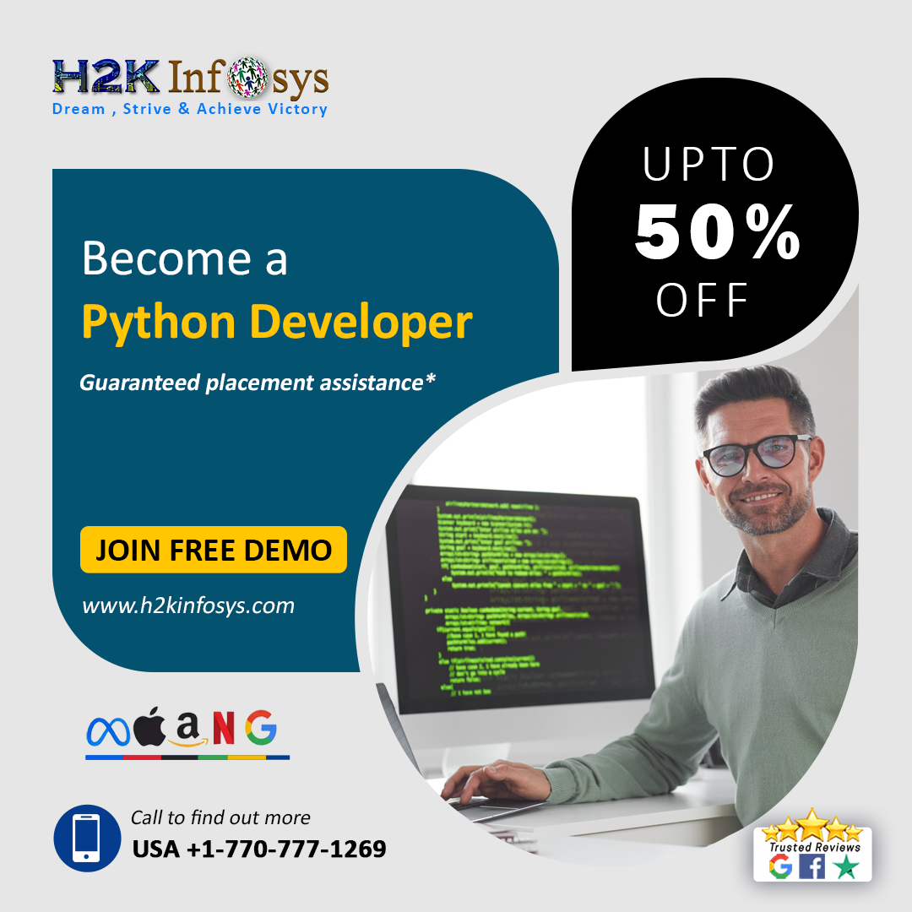](https://www.h2kinfosys.com/courses/python-online-training/)

**Loop Structures in Python**:

* When you know how many iterations there will be, the "for" loop is frequently employed. The code block is executed for each item in the sequence as it iterates across a line, like a list or a string.
* When the number of iterations depends on a condition and is unclear, the "while" loop is appropriate. As long as the predetermined condition is still valid, it iterates continuously.
* Additional flexibility is provided within loop structures by loop control statements like "break" and "continue." The "break" command abruptly ends the loop, whereas the "continue" statement advances to the next iteration without skipping the current one.
* Nested loops can handle more sophisticated scenarios, such as iterating across multidimensional data structures or carrying out intricate actions.

**Conditionals in Python**:

* Suppose a specified condition evaluates to true. The "if" statement enables you to run a code block. It serves as the cornerstone of conditional programming and allows for criteria-based decision-making.
* A different code block is provided to run when the condition evaluates to false via the "if-else" expression. Depending on how the condition turns out, this enables various execution pathways.
* The "elif" phrase, which stands for "else if," enables the sequential evaluation of several conditions. It is beneficial when several potential outcomes or intricate decision trees must be applied.
* To combine criteria and build more intricate decision-making logic, logical operators like "and," "or," and "not" can be utilized.
* To handle complex situations with various criteria and consequences, conditional statements can be nested.

**Best Practices for Loop Structures and Conditionals:**

Use meaningful and descriptive variable names to enhance code readability and maintainability.

* Keep the code within loop structures and conditionals short and focused on improving code clarity and readability.
* For improved code comprehension and teamwork, include comments that describe the goal and reasoning behind the loop or conditional statements.
* Split complex computations or operations into independent functions or methods to retain code simplicity and increase code reuse.
* Test your loops and conditionals with multiple inputs and scenarios to ensure they can handle various circumstances and deliver the desired outcomes.
* To maintain code readability and prevent overly complex logic, limit the amount of loop and conditional nesting.
* To make your codebase consistent and readable, adhere to coding style conventions like Python's PEP 8.

By adhering to these best practices, developers can write clean, efficient, and maintainable code using loop structures and conditionals in Python. These concepts provide the flexibility and control necessary to create robust and interactive programs that meet specific requirements and adapt to different scenarios.

**Why Should You Take A Course?**

An **online** [**Python course with a certificate in H2Kinfosys**](https://www.h2kinfosys.com/) that teaches loop structures and conditionals has various advantages. With a focus on best practices and fundamental ideas, these courses offer a thorough educational experience. You can comprehend loop structures and conditionals thoroughly under the guidance of knowledgeable lecturers. Your programming skills will be strengthened through practical exercises and real-world examples. This certification raises your credibility by demonstrating your competence and dedication to professional growth. The certification's recognition might set you apart from the competition, leading to new job prospects and progress in the Python programming industry.

**Bottom Line:**

The points mentioned above can add more value to your Python knowledge. With this knowledge, you can unlock the full potential of Python and create robust and engaging programs that meet diverse user needs. All you must have is to master in practice and, in the course, to stay calm and composed with proper learning concentration.

Tags: Python, H2kinfosys , Top 10 Online Training Python in GA USA,Across the world high rating Online training for Python, world high rating Python course, World class python training, Live Online Software Training,100 percent job guarantee courses

#onlinecertificatepython #bestpythononlinetraining #Toptenonlinetrainingpython #PythonCourseOnline #PythonGAUSA, #H2KInfosys, #PythonCourse, #LearnPython, #PythonProgramming, #CodingWithPython, #PythonBasics, #PythonIntermediate,#AdvancedPython, #PythonForBeginners,#PythonForDataScience, #PythonForAI,#PythonWebDevelopment,#PythonProjects

Contact: +1-770-777-1269

Mail: training@h2kinfosys.com

Location - Atlanta, GA – USA 5450 McGinnis Village Place, # 103 Alpharetta, GA 30005, USA.

Facebook: <https://www.facebook.com/H2KInfosysLLC>

Instagram: <https://www.instagram.com/h2kinfosysllc/>

Youtube: <https://www.youtube.com/watch?v=p8cNzXQ6Nqk>

Visit: <https://www.h2kinfosys.com/courses/python-online-training/>

Python Course: [https://bit.ly/43SLdfk](https://www.h2kinfosys.com/courses/python-online-training/)

Visit for more info: [H2kinfosys](https://www.h2kinfosys.com/courses/python-online-training/)